1. Variables:

- Numerical variable: Price, Age_08_04, KM, HP, Quarterly Tax, Weight, CC

- Categorical variable: doors, gears

2. Distribution of Price (output)

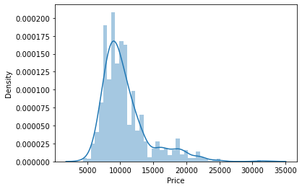

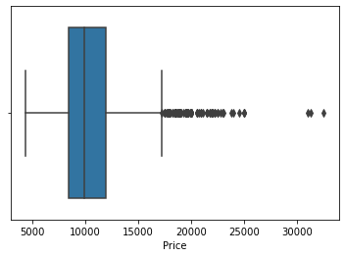

Distribution slightly skewed to the right, with outliers

Price > RM 30000 for sports cars

3. Distribution of numerical variables

i) CC

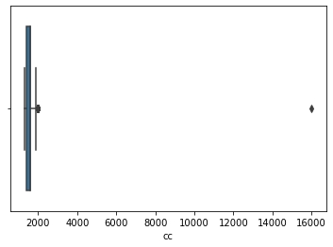For variable ‘CC’, there is extreme value of 16000CC, which is mistyped into data frame, so the value will be replaced with 1600CC, which is also the median value of ‘CC’.

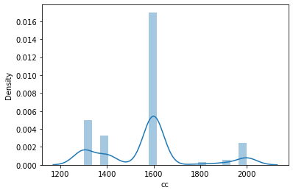

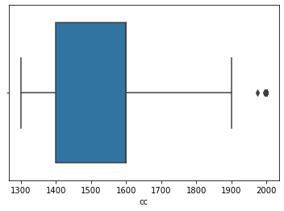

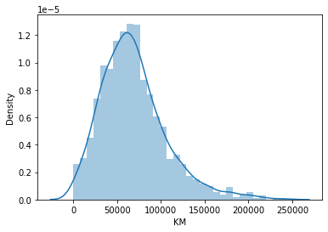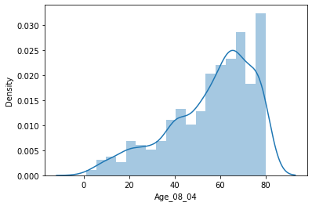ii) Age – Highest frequency around 60-80 iii) KM – Skewed to the right

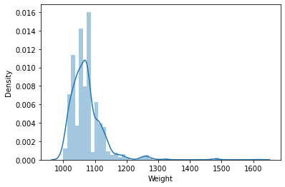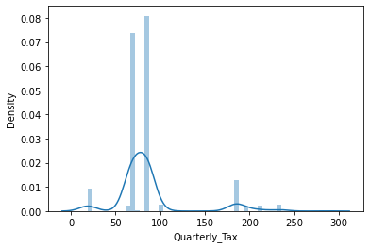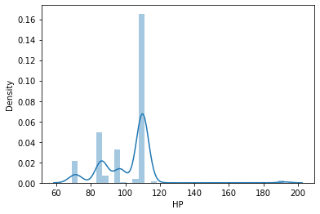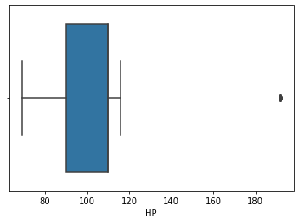iv) HP – outlier value (around 190 due to sports car) v) Quarterly Tax vi) Weight

Mode at 85, highest tax at 280

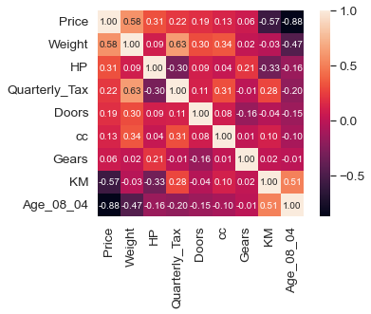4. Multicollinearity between variables based on heatmap:

* Price is highly correlated with Age
* Correlation between Weight and  
   Quarterly Tax is 0.63  
  - Correlation between Price and  
   Weight is 0.58
* Correlation between Price and  
   KM is -0.57
* Correlation between Age and  
   KM is -0.51
* Gears and Price have lowest  
   correlation

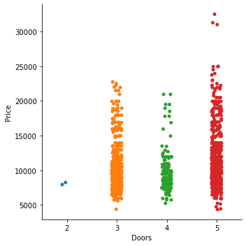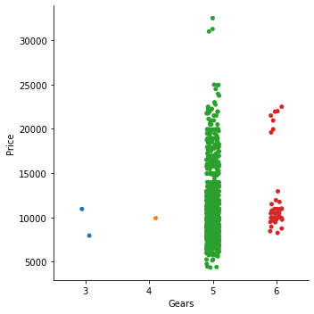

i) Cars with 5 gears are the most cars sold, followed by cars with 6 gears.

ii) Cars with 5 doors sold with higher price range (5000 – 30000), followed by cars with 3 doors (5000 – 20000+).

Based on observation, correlation between independent variables are low. All features do have correlation with dependent variable (Price).

R2 (after replacing outlier in CC) = 0.869

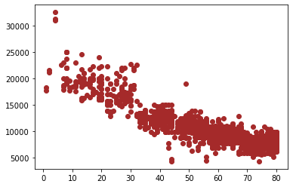Scatter plot of Price against Age – Apply polynomial transformation on Age

**R2 (after polynomial transformation on Age) = 0.888**

Consider only the below columns and prepare a prediction model for predicting Price.

Corolla<-Corolla[c("Price","Age_08_04","KM","HP","cc","Doors","Gears","Quarterly_Tax","Weight")]

test_rmse

1183.3255007296425

train_rmse

1223.9115702176152

Index Price

399 9111.945280461656

478 10239.597798584455

1218 8995.842362382136

1365 8052.307490644231

445 10827.146493089658

1167 7200.075859881825

26 15945.636854085635

102 18072.995688475534

610 6565.988408446901

819 9767.250919482987

247 11984.32240909592

222 12450.287167134387

837 8502.658997632278

1066 7226.4489049973035

1041 10235.94261074131

880 9950.111122674425

1207 8074.12524631118

851 9599.01457645599

58 17758.641673675185

226 12577.871390523364

453 10530.44795692099

1077 6604.609098316292

528 10509.113318483483

657 8482.33168453392

1379 8486.239642452747

1168 7006.244856719559

628 8361.94773575765

931 9638.92269263697

385 9824.21197347961

682 9169.712301508589

1047 8211.893399927376

254 12289.117618250106

143 17858.57601629479

1337 8304.563009521295

483 10033.954975875018

1004 10479.472724999934

301 12198.608864104612

637 8496.52383683677

903 9230.031117948394

1302 8314.502093112373

16 19286.26642904436

390 9129.57953530231

940 9476.112131719014

466 10634.176702956414

969 9317.863271453074

156 18234.9662782293

731 9082.447084388892

65 14819.16331159496

252 12347.587239549037

1243 8682.754866596824

924 8992.077736848032

1375 7353.934440481191

442 10755.293308791845

488 10063.808950697916

910 9718.191780346362

830 9785.959757069346

1059 6295.014100801207

474 10758.316663637655

856 9538.190989179728

1268 7638.510322688788

59 15528.05707700845

1275 8130.509178712502

1013 8832.885013674255

285 13070.42930362228

619 7795.437351022572

234 12506.325761494489

751 10383.461937424285

1211 7076.301883316943

127 17071.949416482992

231 13089.119966674536

911 9960.680687787382

1371 8406.900580128346

1271 8627.061412201037

932 10741.965021089534

1082 7175.906041233176

1319 9364.47756191197

502 10282.006671916799

111 28600.71404931112

1317 7943.619341610418

1223 8639.414601605502

868 9372.542243888318

1015 11161.7909287558

1177 7366.168610141462

394 9858.596445915393

316 12572.081910876983

683 9951.275777527386

1112 8021.656637667202

1212 8901.252742558145

2 16716.57875435878

1359 9136.950602098586

757 9197.424316642524

434 10138.55105594049

732 8591.51315694253

651 8330.298519928661

618 9017.711690421831

675 8467.533570099678

116 22594.99316844277

53 19736.49965739942

1278 8592.863676727085

591 11254.389644038503

1049 5771.043595799914

1343 8633.254723230182

1035 10704.518907173524

7 16360.183508949593

645 8457.800208901177

105 17446.5085567649

1130 7907.426503637242

529 11162.910135697639

126 15905.819823924308

922 9473.867919702407

323 11758.852477134333

250 13837.815630438372

124 18056.207311898062

71 14142.87204475232

1057 5995.617018757521

266 12368.45768397244

1053 6350.906535961714

978 9502.963209835169

644 8853.661975820127

726 9476.069437478018

831 9046.791846307622

914 9913.501391966325

668 8060.480930507441

537 10799.320745424482

198 10540.926049897811

1136 6895.926267768142

575 11649.179825144834

38 14840.764612384168

719 8541.969144633485

262 11773.846103862303

180 19312.39996248355

1179 7848.828326243107

1023 9719.17009431784

1341 8917.241709353013

173 20091.529348999808

979 8670.077700376802

364 13599.57471287625

814 9501.916697177632

1203 8122.988301672984

1242 8544.605971385296

17 16473.80839475222

555 11365.973187751495

542 10438.209005116958

1360 8723.560179720862

217 11194.77020909735

426 10341.316006846544

139 17665.948067610872

279 12846.209436545572

614 9030.577475107963

1304 8486.040255570897

181 20487.906874375527

976 9334.631160772362

1273 7035.580966833157

968 9875.775713043053

287 12318.40001162681

1323 8844.576009355766

1111 8562.258830208719

855 8670.990243405553

271 13167.672434056365

701 8991.222216253434

977 9179.62412351386

106 17535.647304534257

131 17160.65885737593

1146 7941.933173121208

482 10913.695087161785

9 14604.748491609564

531 10184.204234079338

1182 8791.329012242752

46 17252.515433638957

205 10925.544669800427

958 8577.139940948127

985 10469.228446319286

1153 7915.118706561185

915 10778.377915724786

1272 9468.464229987185

1241 9045.934135817575

900 8436.241455547544

1024 11011.212153403108

107 17921.167103121235

690 7617.589642502078

1267 9044.32518785437

298 13757.588625517157

1187 8070.441214063521

584 10453.770287062238

85 16398.311836195004

578 10642.031611545368

392 10243.2166228346

1279 7526.547636785675

1294 8678.977661964444

257 11178.454351840875

766 9273.39841141154

96 17179.050359707915

558 12132.805445221604

22 15393.999270436245

1410 7665.414963048157

1229 8429.866386427653

841 7935.876634718876

280 13359.860680836222

305 12566.637242066046

1409 9385.309481589607

1382 9068.803566151117

1122 9273.859701978261

909 8452.677338888076

1062 5831.675862716451

1230 8477.791538086556

1355 8962.396566225532

1036 9615.02710832392

294 12760.507895810224

274 12446.014993205565

313 12887.578369045836

1420 9526.335982004643

379 7964.136999322071

1038 9814.56003063079

1254 8165.324681604343

617 7433.691004271393

200 11476.543330038909

937 9627.860323712111

8 20061.686377043196

345 13305.547877002864

1303 8725.138808690268

27 15471.415849731291

123 17391.192611145438

310 13114.444122051731

663 8175.742200489671

1431 8965.037034965735

807 7982.611633001026

906 9288.677605462553

697 9003.508313523991

626 8884.663248248376

253 12980.7811412835

177 20532.103054589068

1419 8959.359937844998

993 10858.100917130154

1257 7600.097118631069

1095 7427.799144774712

272 12888.018611815154

517 9745.74729540461

411 10081.649453629663

556 12290.862725768662

735 9679.604317453288

1092 7589.966642289518

1110 7627.827074798977

708 9043.261945301054

1165 8831.995404407935

606 7454.343210842139

580 10958.486808771973

755 8328.041212914419

1009 10175.625488269594

1265 7961.713210584076

660 7701.692755687771

365 12086.706192735193

1309 8948.83789080368

278 11435.278684581357

887 9089.41472282258

727 9324.267190835828

472 9956.316237987936

566 10354.024266525474

615 7356.003394764581

56 15417.745982805824

77 16076.953375690293

221 21481.124413289443

860 8589.725985635121

882 8773.618737721574

265 13145.456712072222

1331 7679.892382392263

191 8834.604248842317

1014 10903.610780201476

1434 8795.494379915057

954 9497.97239082087

1052 6808.325327701425

79 15427.646416241996

45 18166.358512802522

1105 7438.865063441139

429 10945.14640299367

410 9836.08553857342

1139 7901.406103929876

536 10806.268596448383

455 9727.06370619535

193 11324.173063560509

693 7789.905458082558

1134 7983.612834024885

1174 7784.469045642534

499 9966.64569032519

422 10329.820801939402

827 10187.81500175202

858 10016.369429219054

317 12292.14518098576

1055 6774.007876099292

275 12739.053777675264

1108 7703.943696367795

509 11638.72561280433

742 9524.900118355672

787 9366.841790453223

1151 7531.021458441763

1370 9085.078749405475

1005 9919.682501364141

745 8176.832814285255

553 11351.088824518834

325 12966.666892401518

885 10076.776415396964

147 19183.12397317453

1417 9290.570885447387

658 8651.920076517692

175 20505.244773527287

471 9517.2816971026

1351 8943.667325273625

695 8491.884170416131

1256 7436.792315387727

363 13288.713926641914

1021 8410.025436715652

744 8048.600123980792

100 17473.83070381575

368 12882.929956369873

711 8805.214911290339

54 16972.494105233483

144 18746.092941700623

1239 7288.904146519109

1143 8853.694738743521

935 10653.50485894925

743 9456.41063260919

1027 10975.35662017393

508 11433.466044856941

677 8693.523699670093

286 12927.022195121108

72 16056.81480266586

696 8744.479489755364

81 15779.349918560612

1310 8891.189884936037

1407 9811.42859658213

414 10147.307794676504

905 9275.878634925884

146 18436.229675891147

1430 8167.480860281759

1353 8958.243546363272

1196 7423.302059388481

157 19507.429942934483

510 10907.925917781542

473 9949.762747660123

842 10726.217976613974

1219 8280.95070718951

852 9254.183911296815

391 9672.643861991712

360 12668.603331503793

211 14053.303162840493

1001 9192.667633306895

135 17395.70220081323

4 15766.062087496734

284 12774.227250010863

1107 7958.928793948962

853 9455.232399621977

810 8939.05654588352

1018 10087.452487149289

590 11393.502175931784

638 9145.418258518741

351 12633.99418795419

532 10737.722048723728

292 13134.021451275916

1100 7561.998293079272

1295 7941.850269610957

92 20241.809081977226

1390 9259.79469107911

341 12513.770369132173

1067 6589.162386581762

1071 7842.538043953843

1233 7733.702932544689

57 15783.782836516972

938 9193.52930227602

793 9760.755230535458

661 9611.774219175739

642 7788.4034692229525

302 12235.03386711246

462 11450.185233156022

291 13101.579053480322

1220 8705.942558548142

799 9017.081670998556

1169 8794.040969952832

403 10336.672664831465

733 8373.42884791973

809 8299.700144592933

1030 8470.500621579624

803 9618.737587915639

782 10096.609798717618

1352 9350.971928111283

138 21829.6874032644

90 16659.29455164037

133 17964.840297592

862 9780.70225343489

1056 7319.290572973601

1081 7988.416151791696

31 16484.76646799529

1358 8816.3255560685

894 9453.049620210122

32 15642.07935721706

1106 7364.916846249278

1096 7485.330587009168

194 11292.328488178207

1094 7400.532241436191

1320 8745.779233048686

261 12971.677606206964

435 10655.052798517841

1017 9459.360819845138

1026 11410.525130992575

547 9977.742276795429

792 9286.866893410608

1347 8636.45980618214

342 12545.33766255901

704 7854.097471336816

428 10937.286504425221

764 9612.36451156953

140 17283.569939328107

218 10790.36972881473

1046 6022.137057332595

1127 8509.418420413353

511 11415.423716638554

51 14829.441641464065

884 10445.972171302521

1259 9066.12605892603

507 10554.736574059802

734 9533.230567204104

269 12250.869329712936

1398 9387.623124881055

236 12095.940846510079

538 9829.23900481213

634 10552.308766230592

1114 8113.0400929205825

1069 7246.976709501452

605 5670.177323586093

877 10434.361345000754

1102 8031.838358036875

934 8508.941254887824

1128 8122.612854742565